Interview question for SQL

**Employee**

|  |  |  |  |  |
| --- | --- | --- | --- | --- |
| EmpId | Name | ManagerId | DOJ | City |
| 121 | John | 321 | 1/31/2016 | hyd |
| 321 | David | 986 | 1/30/2018 | Chennai |
| 421 | Scott | 876 | 27/11/2020 | Mumbai |

###### **Ques.1. Write an SQL query to fetch the EmpID and Name of all the employees working under Manager with id - “986”**

|  |
| --- |
| SELECT EmpId, Name FROM Employee Where ManagerId = 986; |

**Salary**

|  |  |  |  |
| --- | --- | --- | --- |
| EmpId | Project | Salary | Variable |
| 121 | P1 | 20000 | 0 |
| 321 | P2 | 35000 | 1000 |
| 421 | P1 | 50000 | 3000 |

###### **Qres.2. Write an SQL query to fetch the different projects available from the Salary table.**

|  |
| --- |
| SELECT DISTINCT(Project) FROM Salary; |

###### **Qres.3. Write an SQL query to fetch the count of employees.working in Project ‘P1”.**

|  |
| --- |
| SELECT COUNT(*) FROM Salary WHERE Project = 'P1'; |

###### **Qres.4. Write an SQL query to find the maximum, minimum, and average salary of the employees.**

|  |
| --- |
| SELECT Max(Salary), Min(Salary), AVG(Salary) FROM salary; |

###### **Qres.5. Write an SQL query to find the employees id whose salary lies in the range of 30000 and 40000..**

|  |
| --- |
| SELECT Empld, Salary FROM Salary WHERE Salary BETWEEN 30000 AND 40000; |

Employee

|  |  |  |  |  |
| --- | --- | --- | --- | --- |
| EmpId | Name | ManagerId | DOJ | City |
| 121 | John | 321 | 1/31/2016 | hyd |
| 321 | David | 986 | 1/30/2018 | Chennai |
| 421 | Scott | 876 | 27/11/2020 | Mumbai |

###### **Qres.6. Write an SQL query to fetch those employees who live in Chennai and work under the manager with ManagerId - 986.**

|  |
| --- |
| SELECT EmpId, City, ManagerId FROM Employee WHERE City='Chennai' AND ManagerID='986'; |

###### **Qres.7. Write an SQL query to fetch all the employees who either live in Chennai or work under a manager with ManagerId - 321.**

|  |
| --- |
| SELECT EmpId, City, ManagerId FROM Employee WHERE City='Chennai' OR ManagerID='321'; |

Salary

|  |  |  |  |
| --- | --- | --- | --- |
| EmpId | Project | Salary | Variable |
| 121 | P1 | 20000 | 0 |
| 321 | P2 | 35000 | 1000 |
| 421 | P1 | 50000 | 3000 |

###### **Qres.8. Write an SQL query to fetch all those employees who work on Project other than P1.**

|  |
| --- |
| SELECT EmpId FROM Salary WHERE NOT Project='P1'; (Or) SELECT EmpId FROM Salary WHERE Project<>'P1'; |

###### **Qres.9. Write an SQL query to display the total salary of each employee adding the Salary with Variable value.**

|  |
| --- |
| SELECT EmpId, Salary + Variable as TotalSalary FROM Salary; |

Employee

|  |  |  |  |  |
| --- | --- | --- | --- | --- |
| EmpId | Name | ManagerId | DOJ | City |
| 121 | John | 321 | 1/31/2016 | hyd |
| 321 | David | 986 | 1/30/2018 | Chennai |
| 421 | Scott | 876 | 27/11/2020 | Mumbai |

###### **Qres.10. Write an SQL query to fetch those employees whose name begins with any two characters, followed by a text ‘’vi” and ending with any sequence of characters.**

|  |
| --- |
| SELECT Name FROM Employee WHERE name like '__vi%'; |

###### 

###### **Ques.11. List out the employees who are not receiving the commission.**

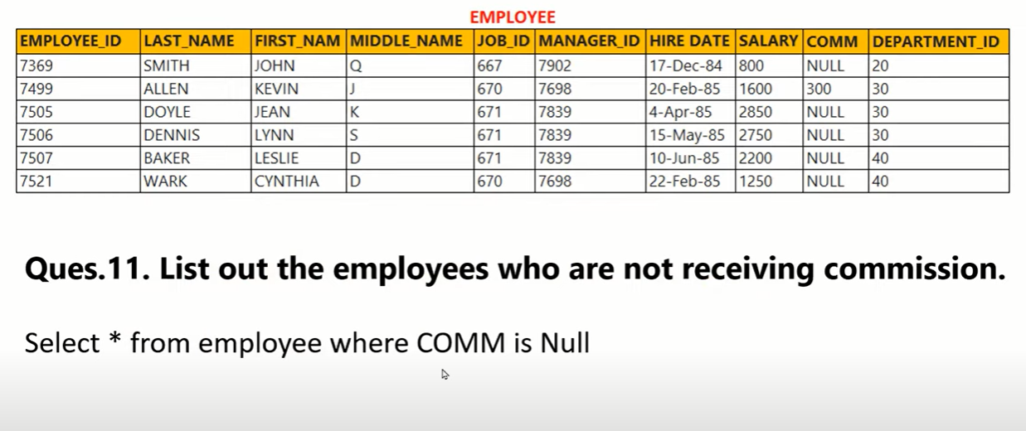

###### **Ques: 12. List out the employees who are working in department 10 and draw the salaries of more than 3500**

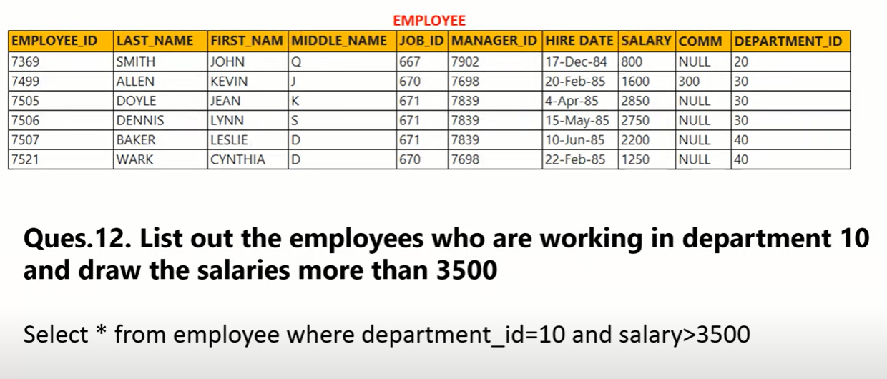

###### **Ques: 13. List out the employee id, name in descending order based on the salary column**

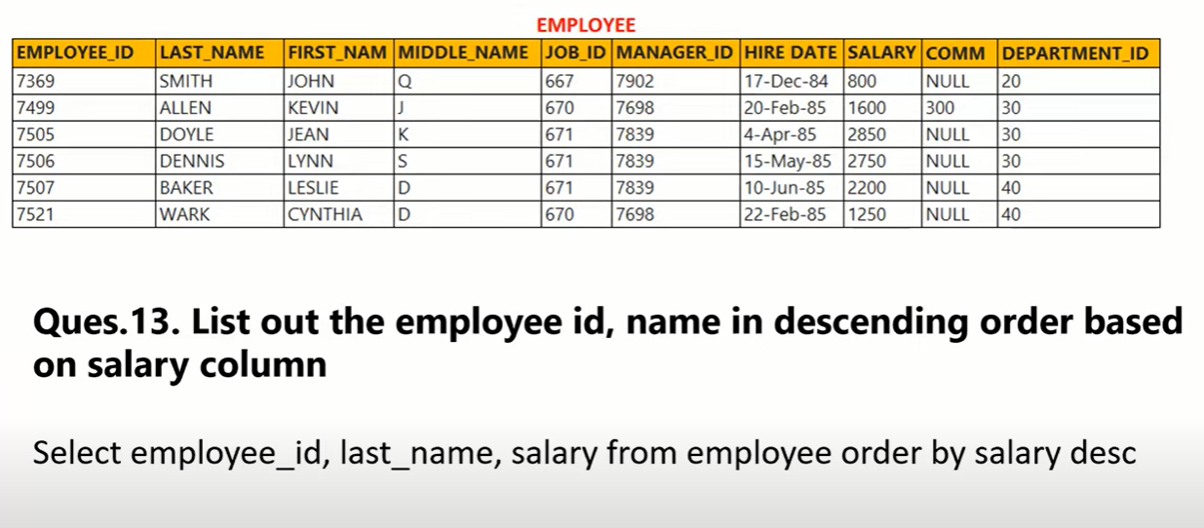

###### **Ques: 14. How many employees, who are working in different departments, are wise in the organization.**

###### **Ques: 15. List out the department id having at least 3 employees.**

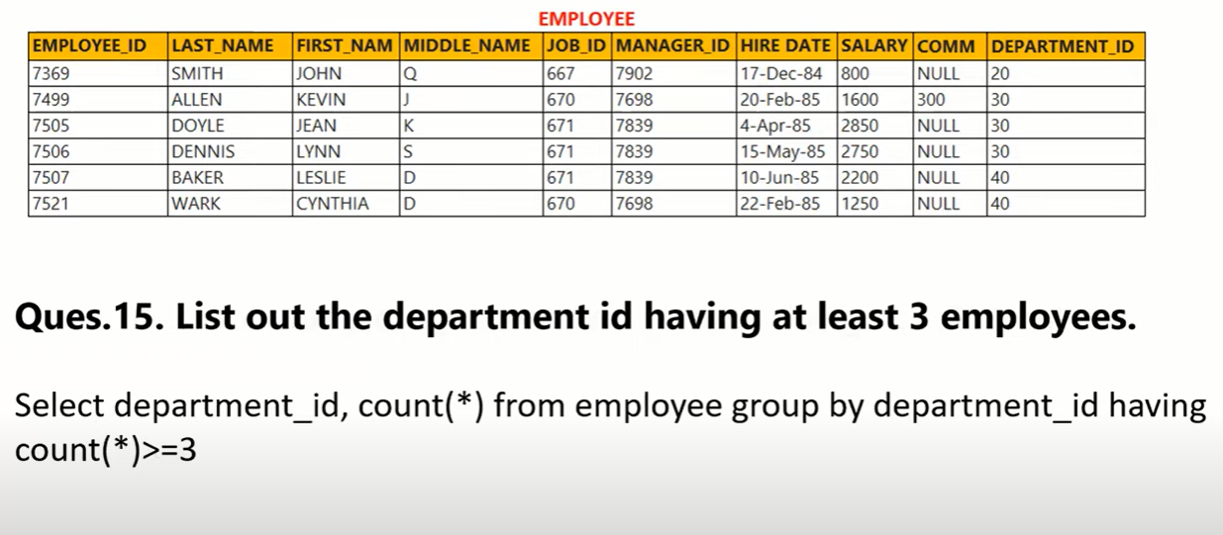

###### **Ques: 16. Display the employees who got the maximum salary.**

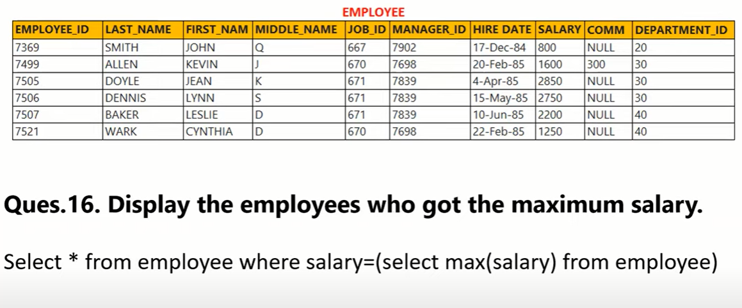

###### **Ques: 17. Display the employees who are working in the Sales department.**

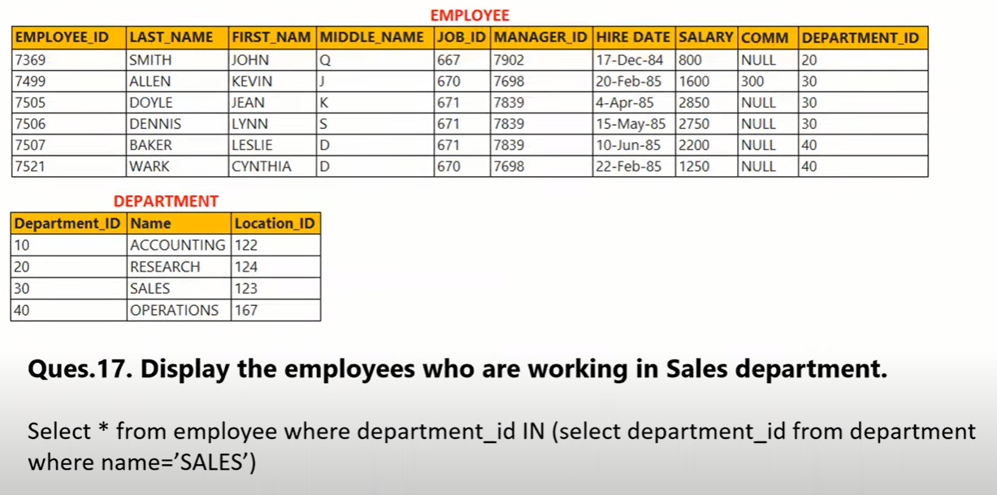

###### **Ques: 18. Display the employees who are working in “New York”**

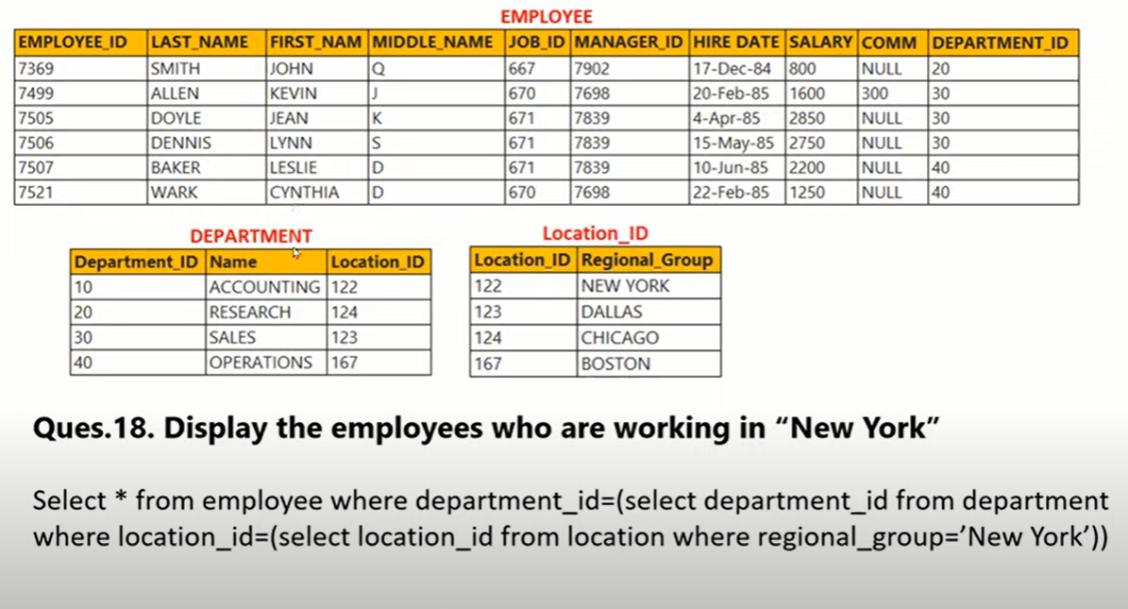

###### **Ques: 19. Update the employees’ salaries, who are working as Manager on the basis of 10%**

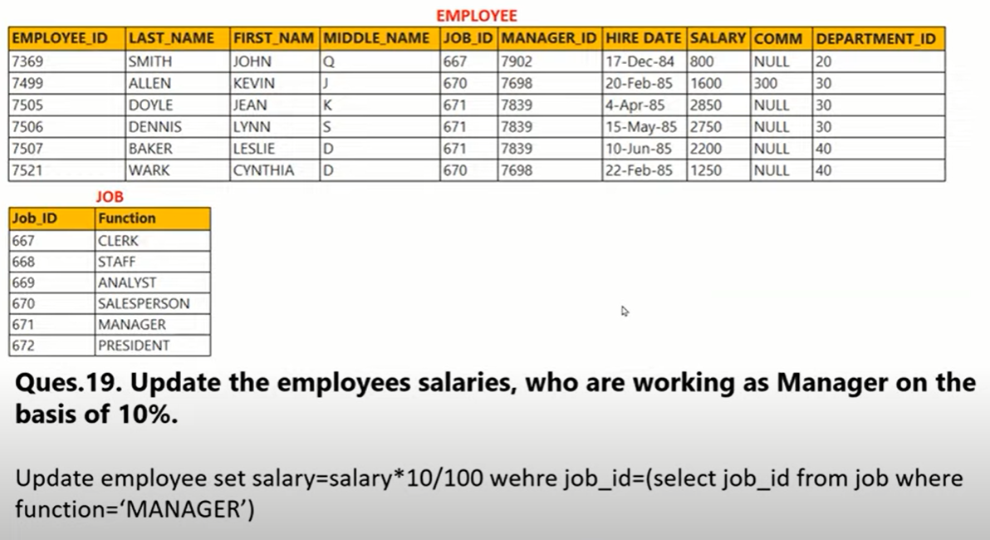

###### **Ques: 20. Delete the employees who are working in the accounting department.**

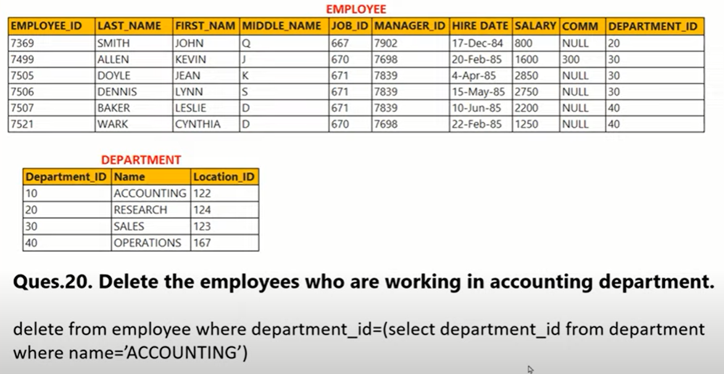

###### Ques: 21. Use of max(), limit & top

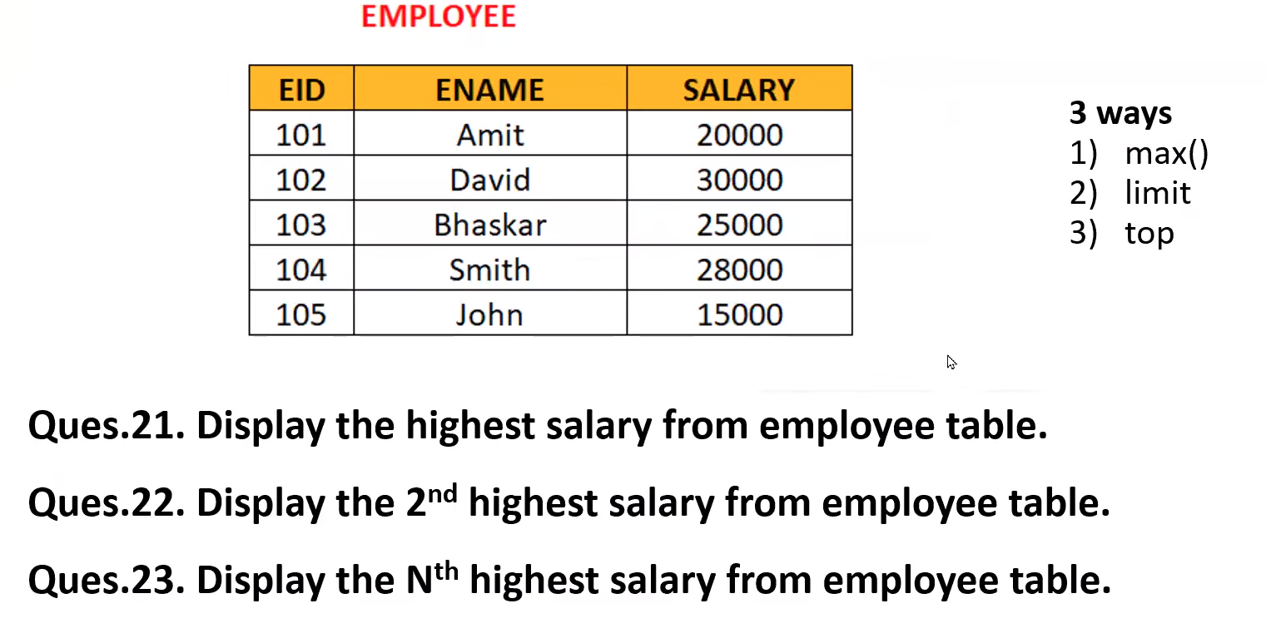

**MAX() function support for all databases, limit support for MySql, and top support for Microsoft SQL only**

|  |
| --- |
| 21. SELECT MAX(SALARY) FROM EMPLOYEE ;  SELECT SALARY FROM EMPLOYEE ORDER BY SALARY DESC LIMIT 1;  SELECT TOP 1 SALARY FROM EMPLOYEE ORDER BY SALARY DESC; |

|  |
| --- |
| 22. SELECT MAX(SALARY) FROM EMPLOYEE WHERE SALARY < (SELECT MAX(SALARY) FROM EMPLOYEE);  SELECT SALARY FROM(SELECT SALARY FROM EMPLOYEE ORDER BY SALARY DESC LIMIT 2) env ORDER BY SALARY LIMIT 1;  SELECT TOP 1 SALARY FROM(SELECT TOP 2 SALARY FROM EMPLOYEE ORDER BY SALARY DESC) env ORDER BY SALARY; |

|  |
| --- |
| 23. SELECT MAX(SALARY) FROM EMPLOYEE WHERE SALARY<(SELECT MAX(SALARY) FROM EMPLOYEE WHERE SALARY < (SELECT MAX(SALARY) FROM EMPLOYEE));  SELECT SALARY FROM(SELECT SALARY FROM EMPLOYEE ORDER BY SALARY DESC LIMIT 3) env ORDER BY SALARY LIMIT 1;  SELECT TOP 1 SALARY FROM(SELECT TOP 3 SALARY FROM EMPLOYEE ORDER BY SALARY DESC) env ORDER BY SALARY; |

###### **Ques: 24 Find nth highest salary using Co-related Sub Query**

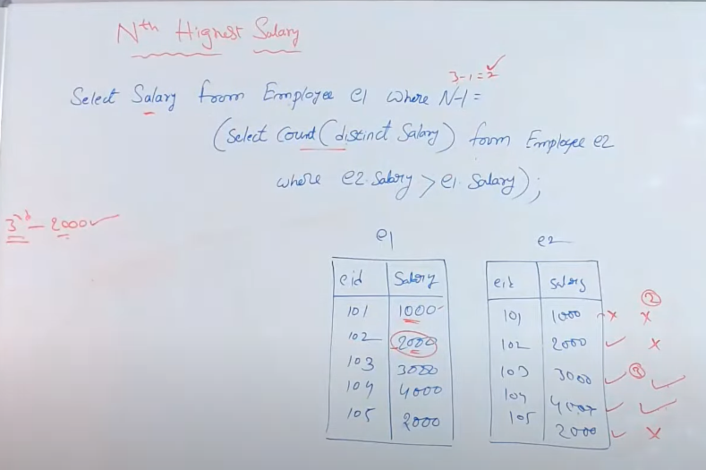

|  |
| --- |
| -Highest SELECT SALARY FROM EMPLOYEE e1 WHERE 1-1 = (SELECT COUNT( DISTINCT SALARY) FROM EMPLOYEE e2 WHERE e2 SALARY > e1 SALARY);  -2nd Highest SELECT SALARY FROM EMPLOYEE e1 WHERE 2-1 = (SELECT COUNT( DISTINCT SALARY) FROM EMPLOYEE e2 WHERE e2 SALARY > e1 SALARY);  -3rd Highest SELECT SALARY FROM EMPLOYEE e1 WHERE 3-1 = (SELECT COUNT( DISTINCT SALARY) FROM EMPLOYEE e2 WHERE e2 SALARY > e1 SALARY);  -nth Highest SELECT SALARY FROM EMPLOYEE e1 WHERE n-1 = (SELECT COUNT( DISTINCT SALARY) FROM EMPLOYEE e2 WHERE e2 SALARY > e1 SALARY); |

###### **Ques: 25 How to delete duplicates from a table?**

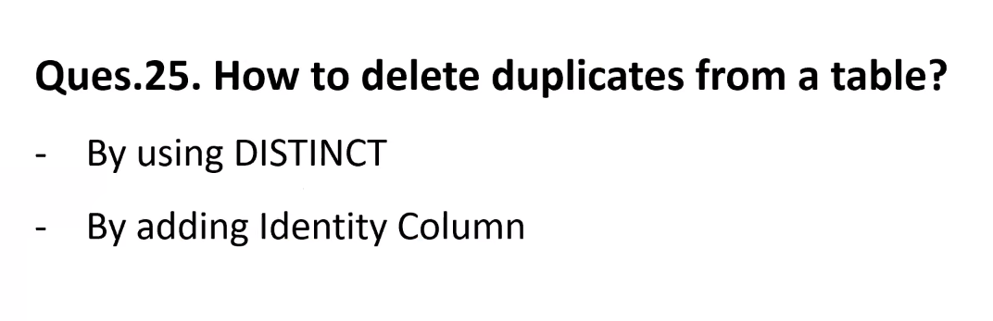

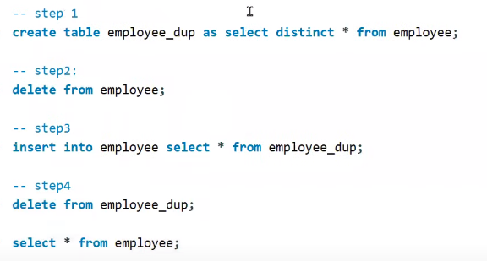

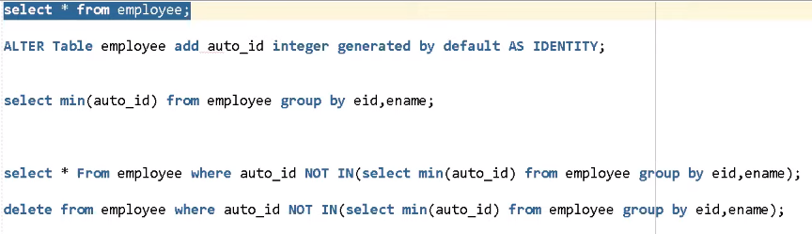

###### Ques: 26. Create a table from the existing table (only structure without data)

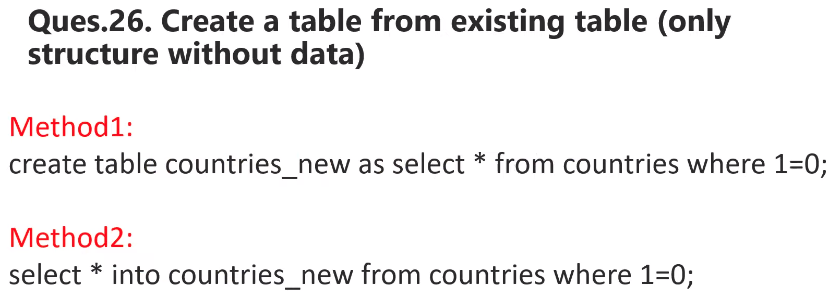

###### **Ques: 27. Do not start with vowels and do not end with vowels + not contain the duplicates**

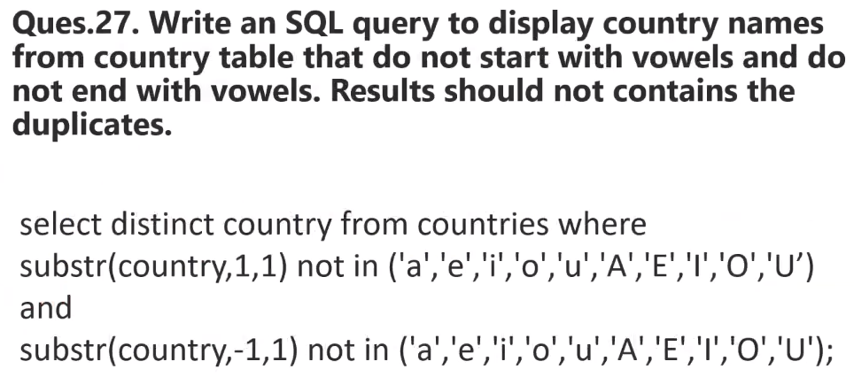

###### Ques: 28 Write an SQL query to find the current date.

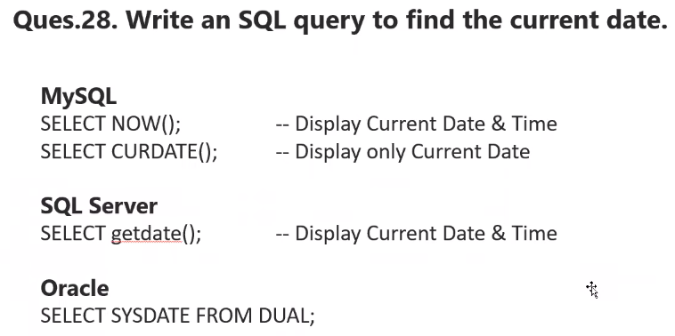

###### **Ques: 29. Write an SQL query to fetch all the DepartmentID’s which are present in either of the tables- ‘Employees’ and ‘Departments’**

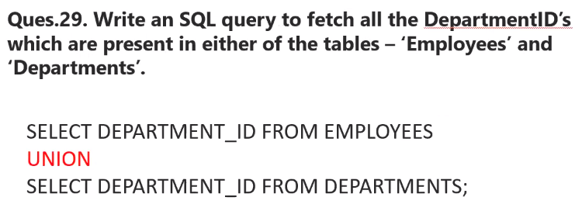



###### Ques: 30 Write an SQL query to fetch common records between two tables.

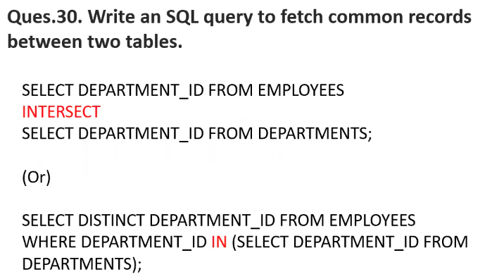

###### **Ques: 31 Write an SQL query to fetch records that are present in one table but not in another table.**

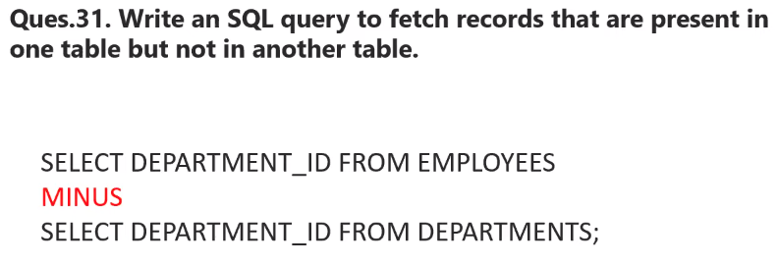

###### **Ques: 32 Query a list of CITY names from STATION for cities that have an even ID number. Print the results in any order, but exclude duplicates from the answer.**

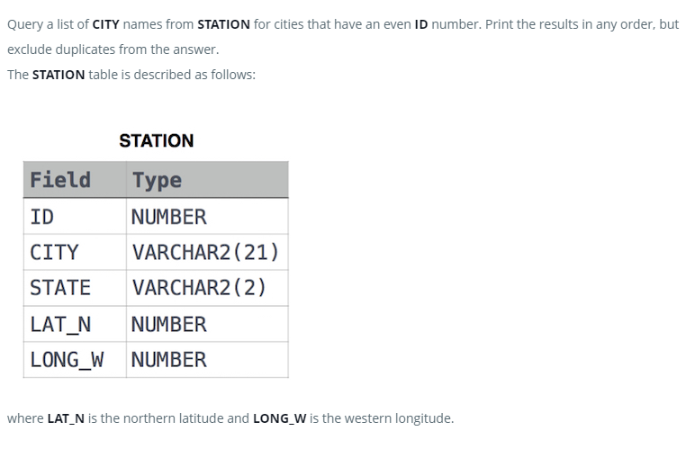

|  |
| --- |
| SELECT DISTINCT CITY FROM STATION WHERE MOD(ID,2)=0 ORDER BY CITY; |

###### **Ques: 33 Query the two cities in STATION with the shortest and longest CITY names, as well as their respective lengths (i.e.: number of characters in the name). If there is more than one smallest or largest city, choose the one that comes first when ordered alphabetically.**

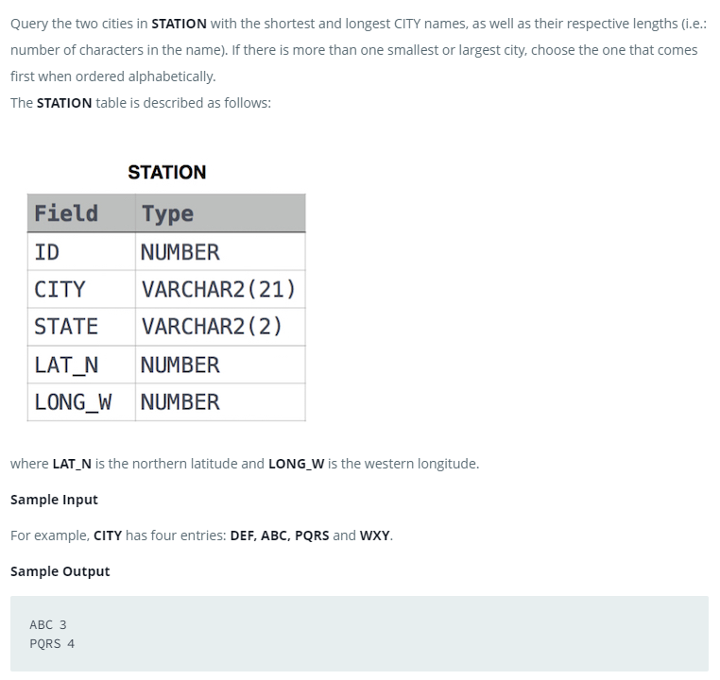

|  |
| --- |
| SELECT CITY, LENGTH(CITY) FROM STATION ORDER BY LENGTH(CITY), CITY LIMIT 1; SELECT CITY, LENGTH(CITY) FROM STATION ORDER BY LENGTH(CITY) DESC LIMIT 1; |

###### Ques: 34

###### Ques: 31

###### Ques: 31

###### Ques: 31

###### Ques: 31

###### Ques: 31

###### Ques: 31

###### Ques: 31

###### Ques: 31

###### Ques: 31